**MONGODB**

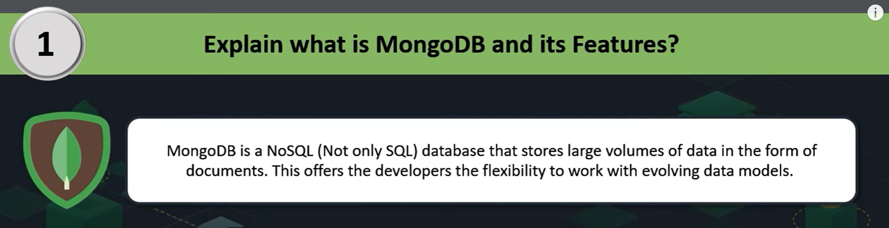

MongoDB is a [NoSQL](https://www.geeksforgeeks.org/introduction-to-nosql/) database, which means it does not use the traditional table-based relational database structure. Instead, it uses a flexible, document-oriented data model that stores data in BSON (Binary JSON) format.

Unlike SQL databases that use rows and columns, MongoDB stores data as [JSON](https://www.geeksforgeeks.org/json/)-like documents, making it easier to handle unstructured data and providing greater flexibility in terms of schema design.

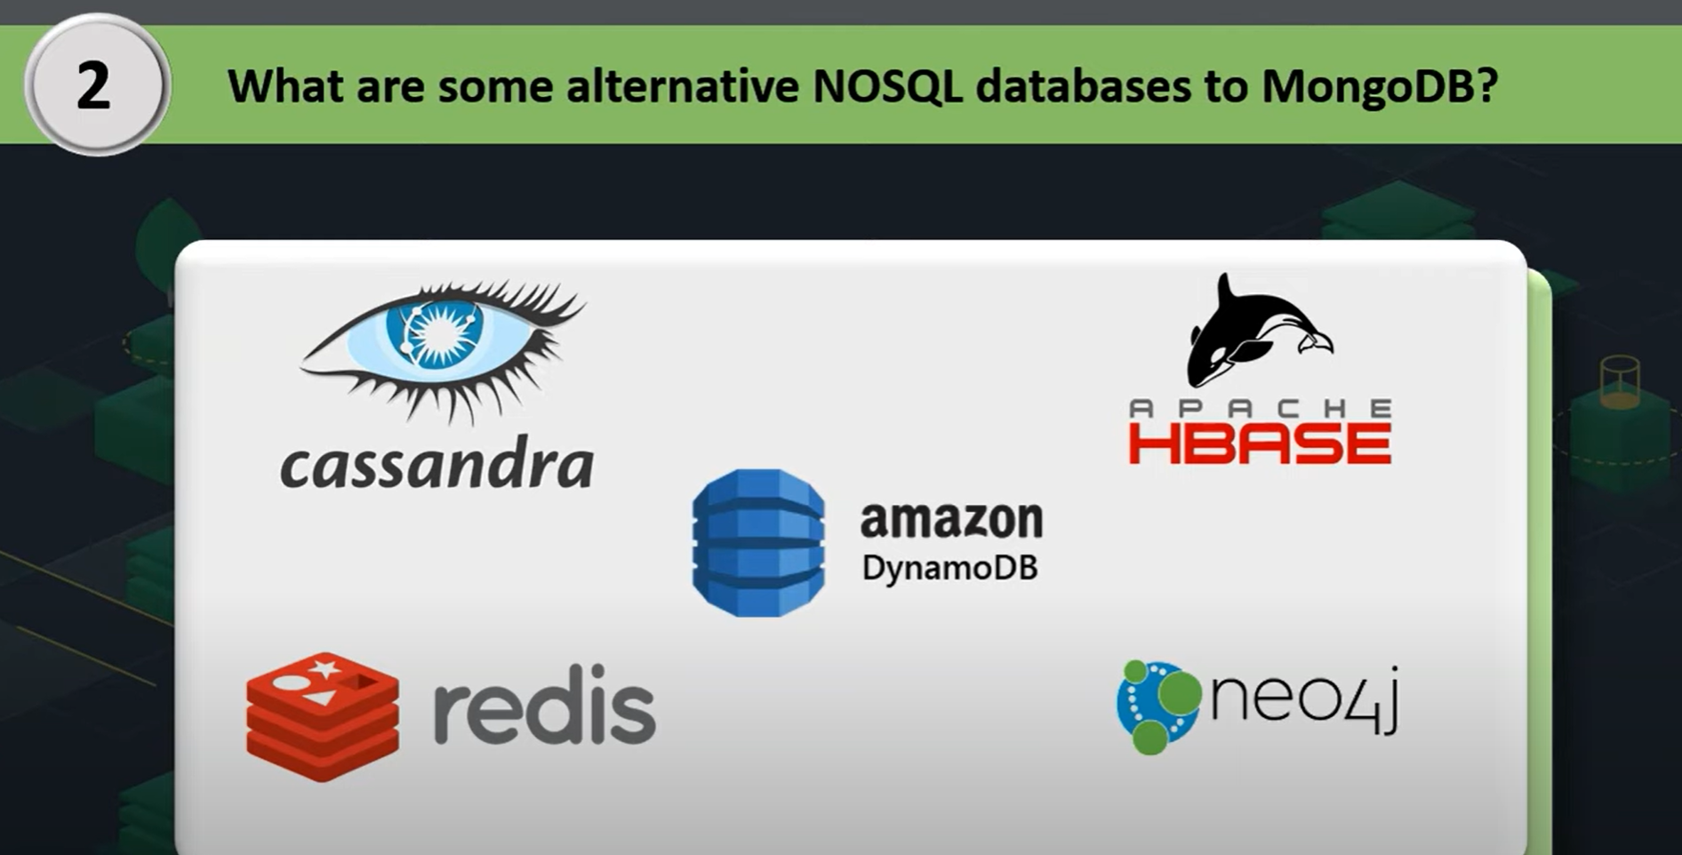

**Explain BSON and Its Significance in MongoDB.**

[BSON](https://www.geeksforgeeks.org/what-is-bson/) (Binary JSON) is a binary-encoded serialization format used by MongoDB to store documents. BSON extends JSON by adding support for data types such as dates and binary data, and it is designed to be efficient in both storage space and scan speed. The binary format allows MongoDB to be more efficient with data retrieval and storage compared to text-based JSON.

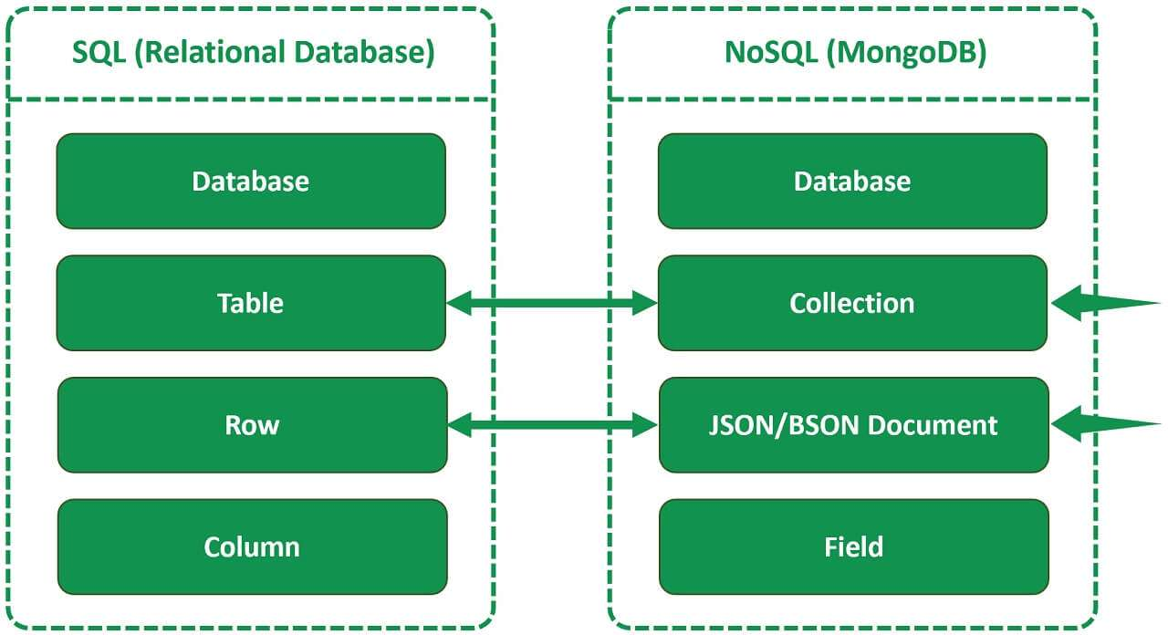

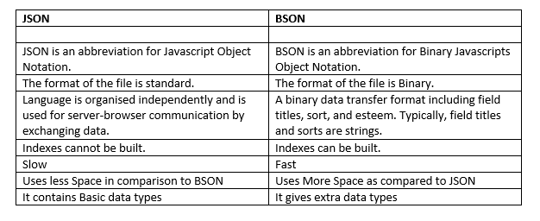

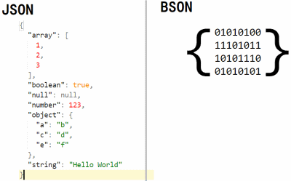

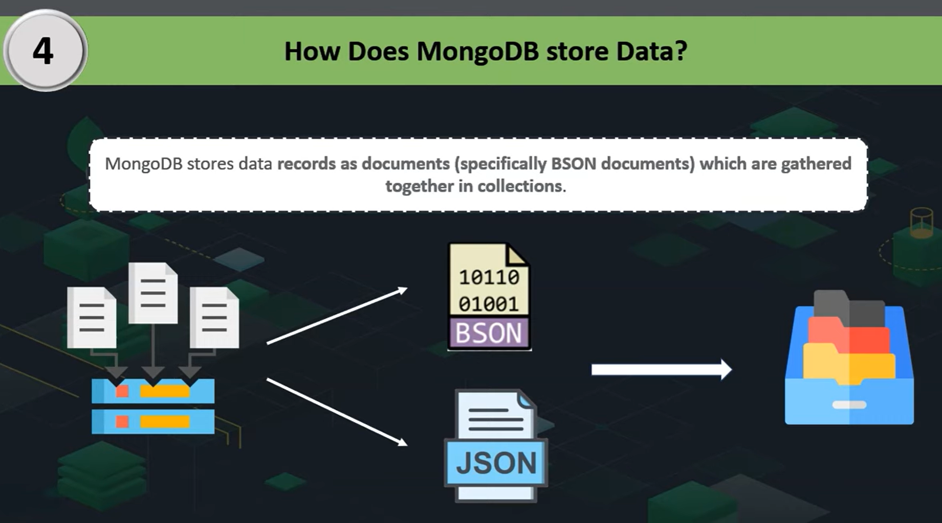



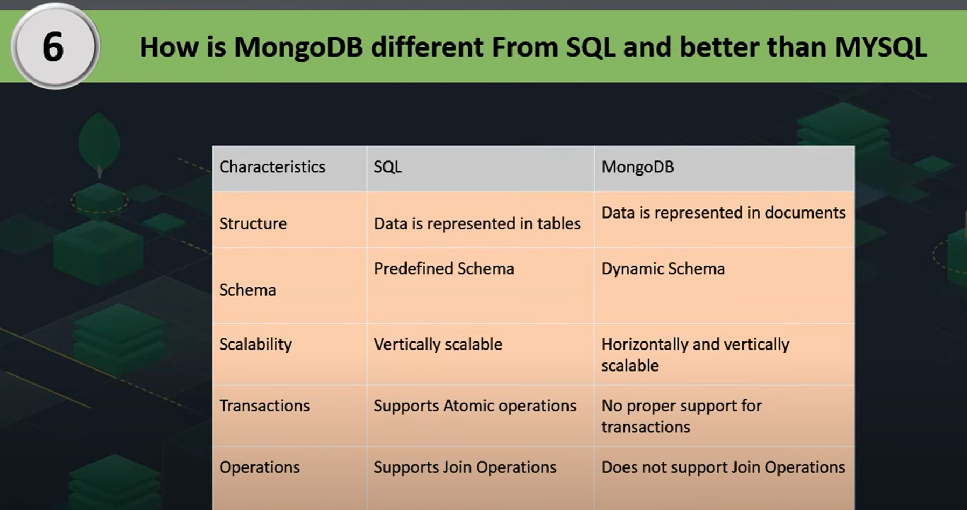

**What are Collections And Databases In MongoDB?**

In MongoDB, a database is a container for collections, and a collection is a group of MongoDB documents. Collections are equivalent to tables in [SQL](https://www.geeksforgeeks.org/sql-tutorial/) databases, but they do not enforce a schema, allowing for flexibility in the structure of the documents they contain. For example, you might have a users collection in a mydatabase database.

**How Does MongoDB Ensure High Availability and Scalability?**

MongoDB ensures high availability and scalability through its features like replica sets and sharding. Replica sets provide redundancy and failover capabilities, ensuring that data is always available. Sharding distributes data across multiple servers, enabling horizontal scalability to handle large volumes of data and high traffic loads.

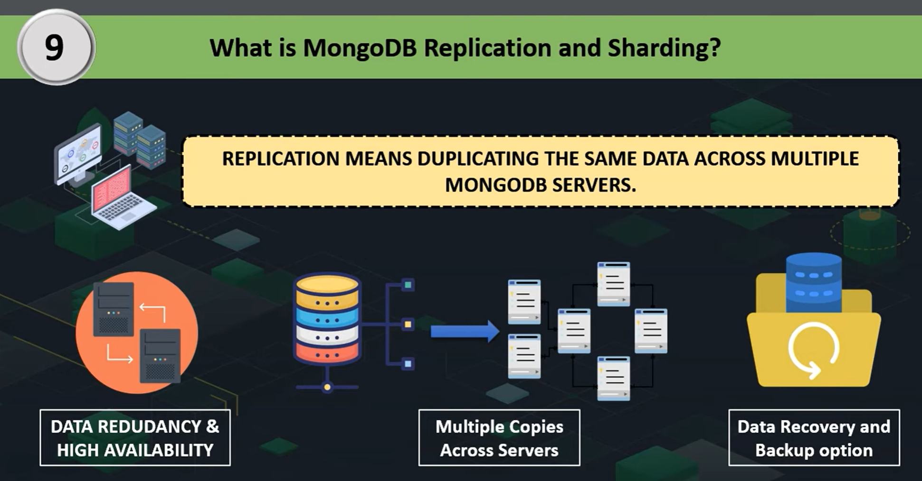

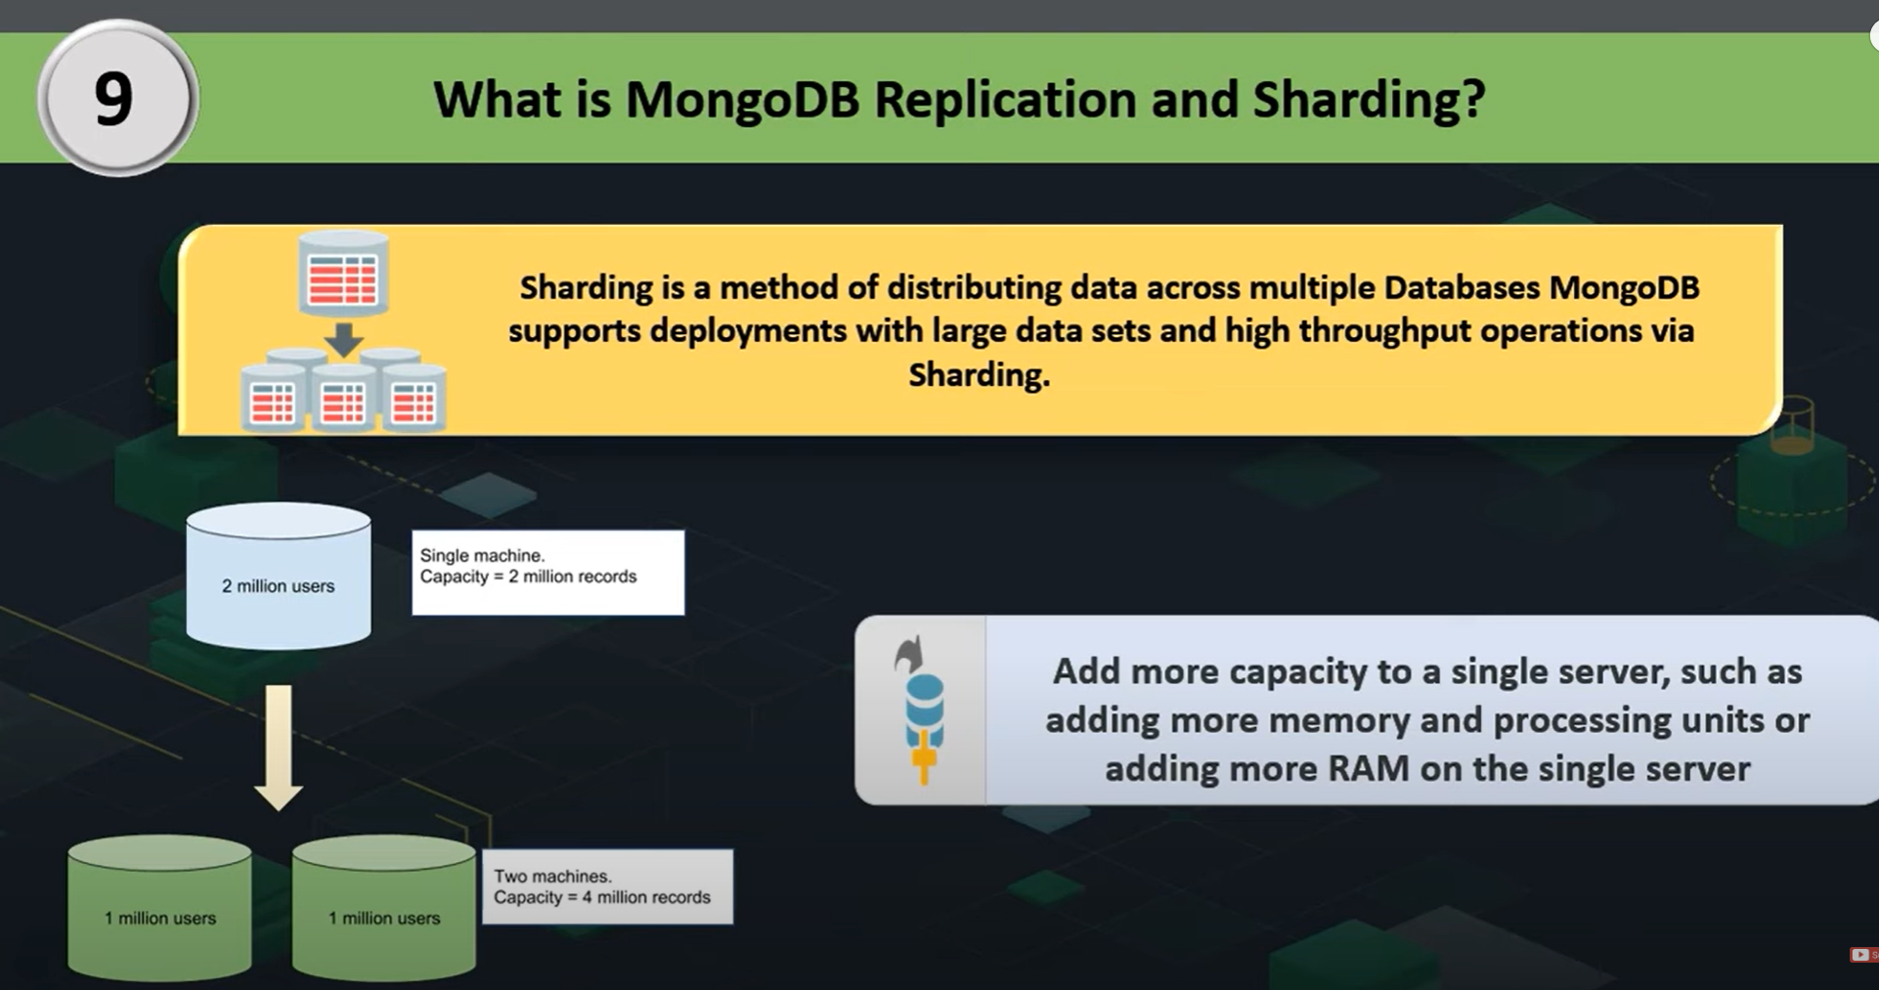

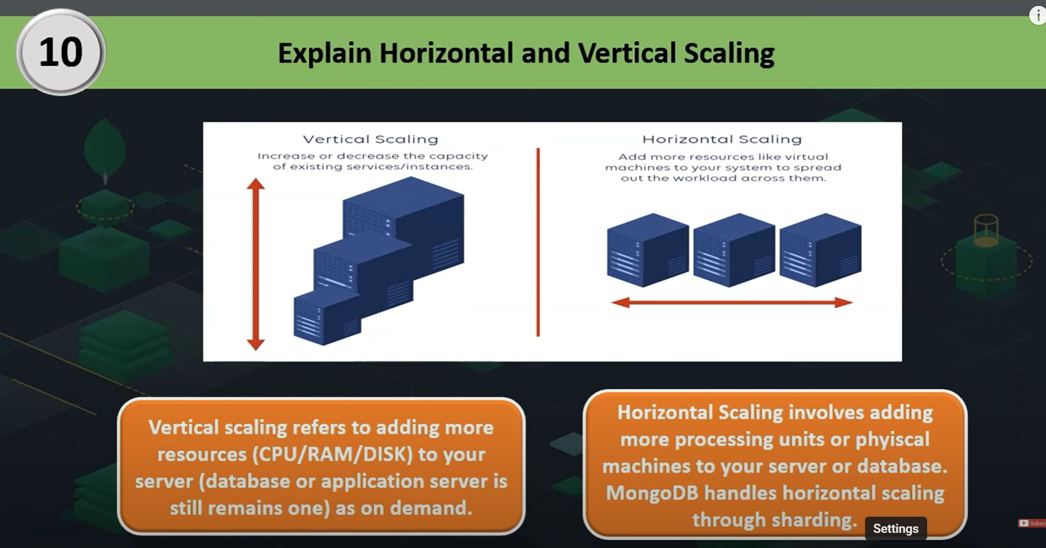

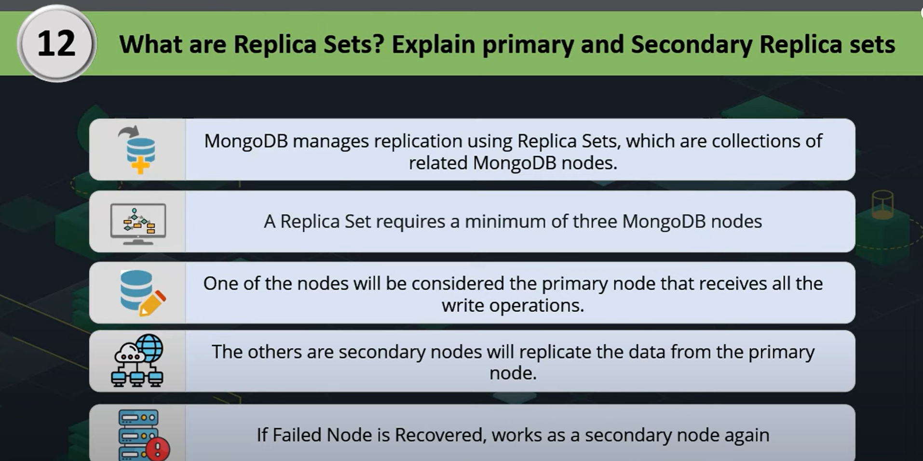

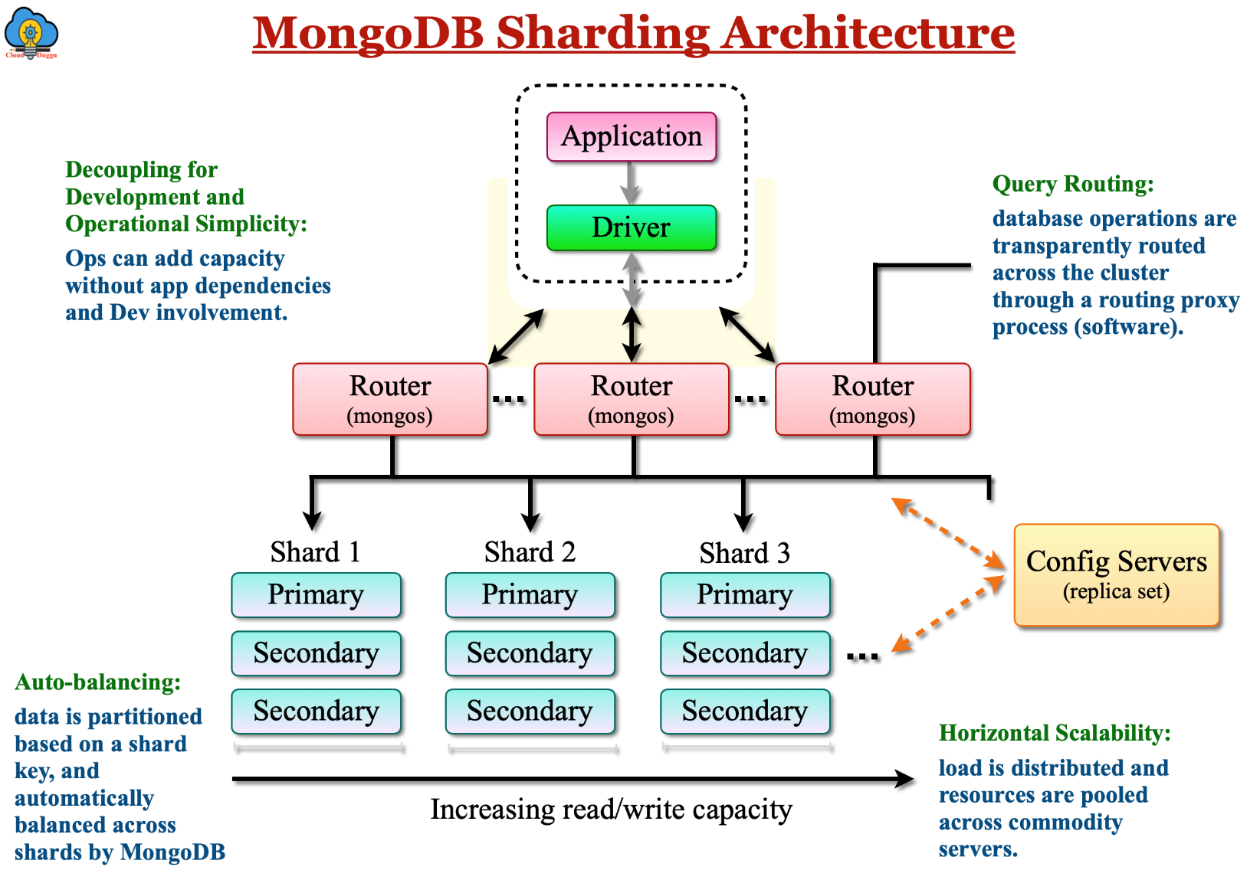

**Explain the Concept of Replica Sets in MongoDB.**

A replica set in MongoDB is a group of mongod instances that maintain the same data set. A replica set consists of a primary node and multiple secondary nodes. The primary node receives all write operations, while secondary nodes replicate the primary’s data and can serve read operations. If the primary node fails, an automatic election process selects a new primary to maintain high availability.

**7. What are the Advantages of Using MongoDB Over Other Databases?**

* Flexibility: MongoDB’s document-oriented model allows for dynamic schemas.
* Scalability: Built-in sharding enables horizontal scaling.
* High Availability: Replica sets provide redundancy and automatic failover.
* Performance: Efficient storage and retrieval with BSON format.
* Ease of Use: JSON-like documents make it easier for developers to interact with data.

**What is Sharding, and How Does It Work in MongoDB?**

Sharding is a method for distributing data across multiple servers in MongoDB. It allows for horizontal scaling by splitting large datasets into smaller, more manageable pieces called shards. Each shard is a separate database that holds a portion of the data. MongoDB automatically balances data and load across shards, ensuring efficient data distribution and high performance.

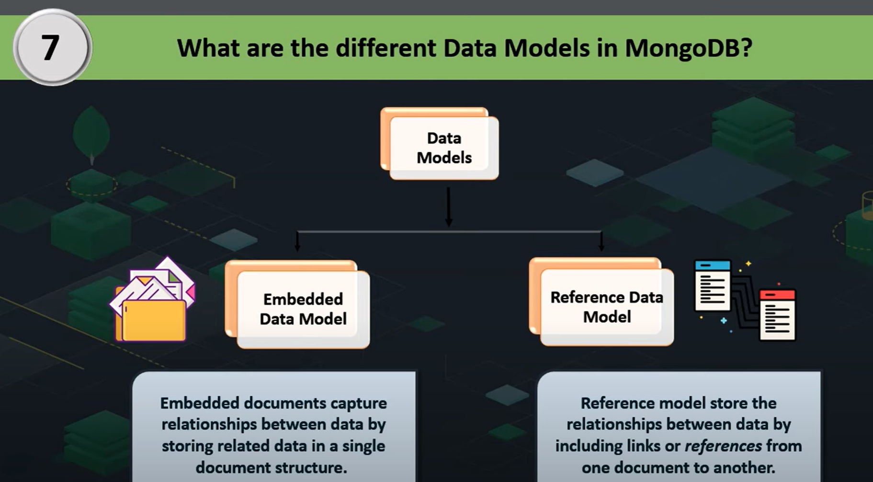

**What is GridFS, and When is it Used in MongoDB?**

GridFS is a specification for storing and retrieving large files in MongoDB. It is used when files exceed the BSON-document size limit of 16 MB or when you need to perform efficient retrieval of specific file sections. GridFS splits a large file into smaller chunks and stores each chunk as a separate document within two collections: fs.files and fs.chunks. This allows for efficient storage and retrieval of large files, such as images, videos, or large datasets.

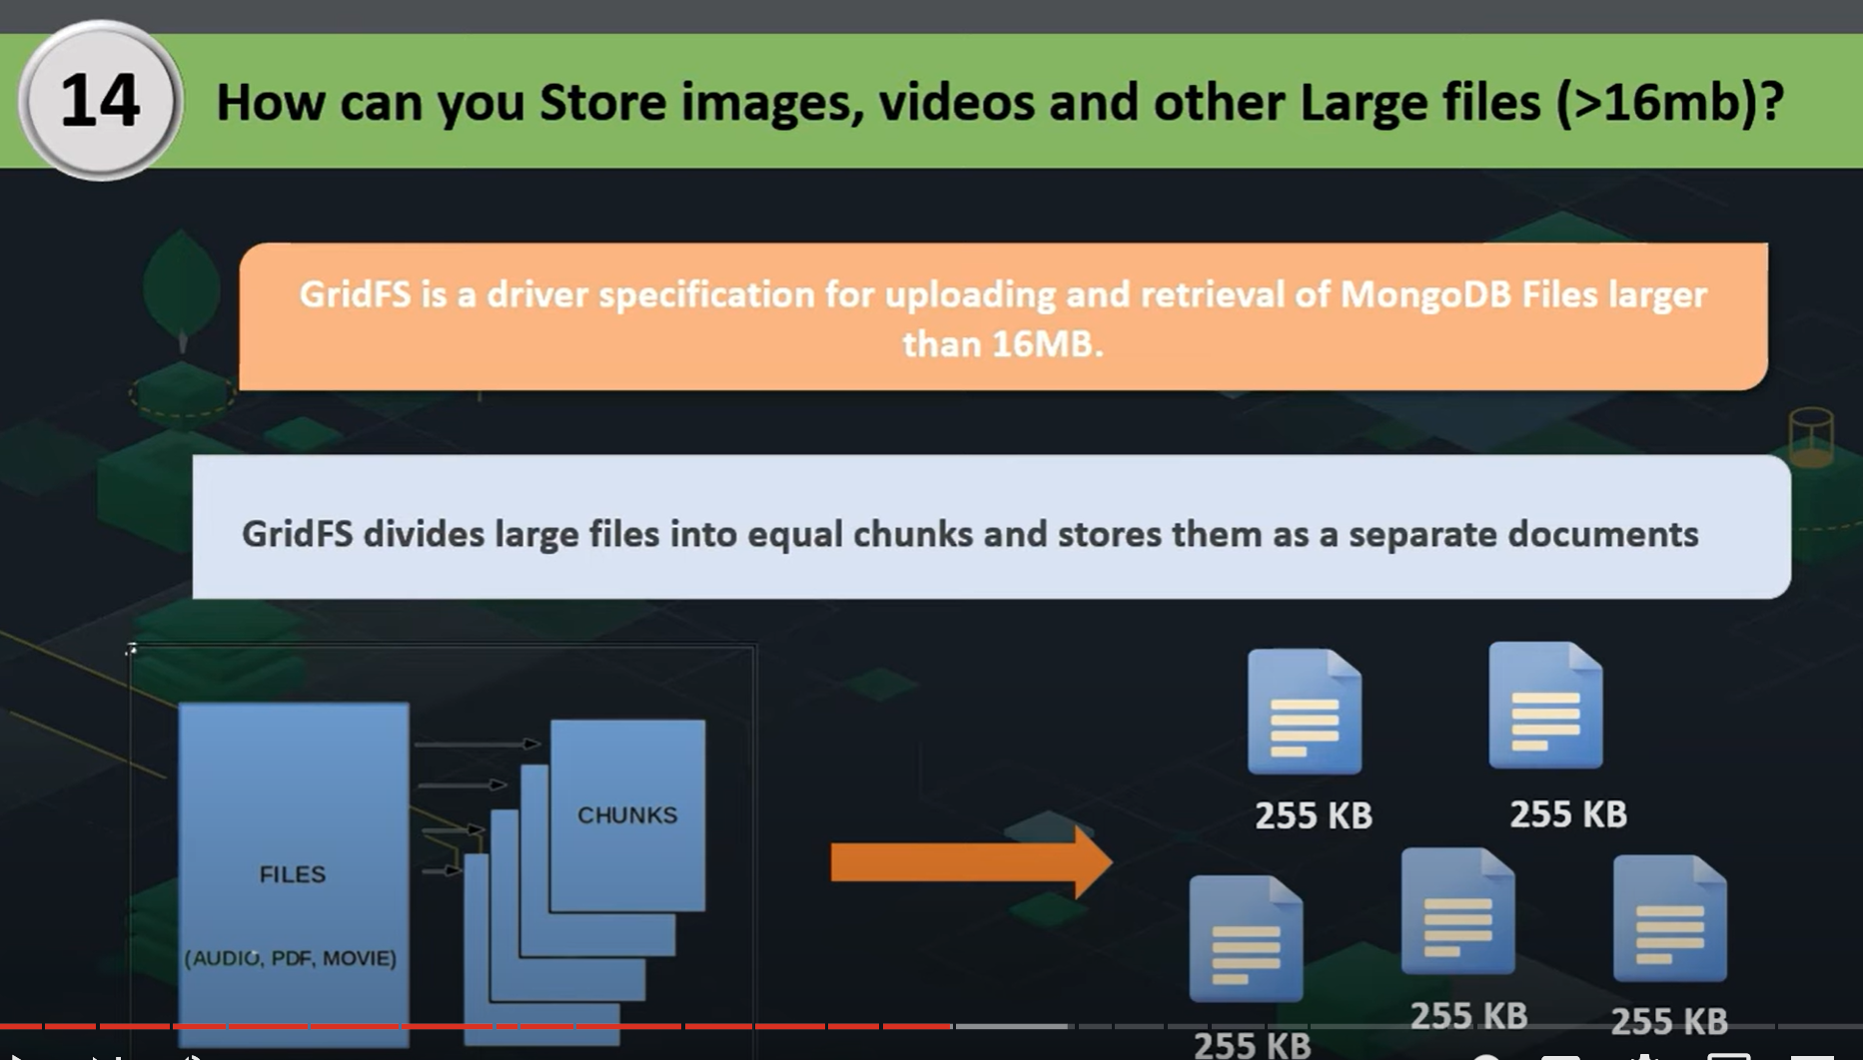

**Explain the Differences Between WiredTiger and MMAPv1 Storage Engines**

WiredTiger and MMAPv1 are two different storage engines in MongoDB, each with distinct characteristics:

**WiredTiger:**

* Concurrency: Provides document-level concurrency, allowing multiple operations to be performed simultaneously.
* Compression: Supports data compression, reducing storage space requirements.
* Performance: Generally offers better performance and efficiency for most workloads.
* Journaling: Uses a write-ahead logging mechanism for better data integrity.

**MMAPv1:**

* Concurrency: Provides collection-level concurrency, which can limit performance under heavy write operations.
* No Compression: Does not support data compression.
* Legacy Engine: It is the older storage engine and has been deprecated in favor of WiredTiger.
* Simplicity: Simple implementation but lacks advanced features compared to WiredTiger.

**How to Handle Transactions in MongoDB?**

MongoDB supports multi-document ACID transactions, allowing you to perform a series of read and write operations across multiple documents and collections in a transaction. This ensures data consistency and integrity. To use transactions, you typically start a session, begin a transaction, perform the operations, and then commit or abort the transaction.

**Example in JavaScript:**

const session = client.startSession();  
  
session.startTransaction();  
  
try {  
 db.collection1.insertOne({ name: "Alice" }, { session });  
 db.collection2.insertOne({ name: "Bob" }, { session });  
 session.commitTransaction();  
} catch (error) {  
 session.abortTransaction();  
} finally {  
 session.endSession();  
}

**What is MongoDB Atlas, and How Does it Differ From Self-Hosted MongoDB?**

MongoDB Atlas is a fully managed cloud database service provided by MongoDB. It offers automated deployment, scaling, and management of MongoDB clusters across various cloud providers ([AWS](https://www.geeksforgeeks.org/aws-tutorial/), [Azure](https://www.geeksforgeeks.org/microsoft-azure/), [Google Cloud](https://www.geeksforgeeks.org/google-cloud-platform-tutorial/)). Key differences from self-hosted MongoDB include:

* Managed Service: Atlas handles infrastructure management, backups, monitoring, and upgrades.
* Scalability: Easily scale clusters up or down based on demand.
* Security: Built-in security features such as encryption, access controls, and compliance certifications.
* Global Distribution: Deploy clusters across multiple regions for low-latency access and high availability.
* Integrations: Seamless integration with other cloud services and MongoDB tools.

**What are Capped Collections, and When are They Useful?**

Capped collections in MongoDB are fixed-size collections that automatically overwrite the oldest documents when the specified size limit is reached. They maintain insertion order and are useful for scenarios where you need to store a fixed amount of recent data, such as logging, caching, or monitoring data.

Example of creating a capped collection:

db.createCollection("logs", { capped: true, size: 100000 });

**Explain the Concept of Geospatial Indexes in MongoDB**

Geospatial indexes in MongoDB are special indexes that support querying of geospatial data, such as locations and coordinates. They enable efficient queries for proximity, intersections, and other spatial relationships. MongoDB supports two types of geospatial indexes: 2d for flat geometries and 2dsphere for spherical geometries.

Example of creating a 2dsphere index:

db.places.createIndex({ location: "2dsphere" });



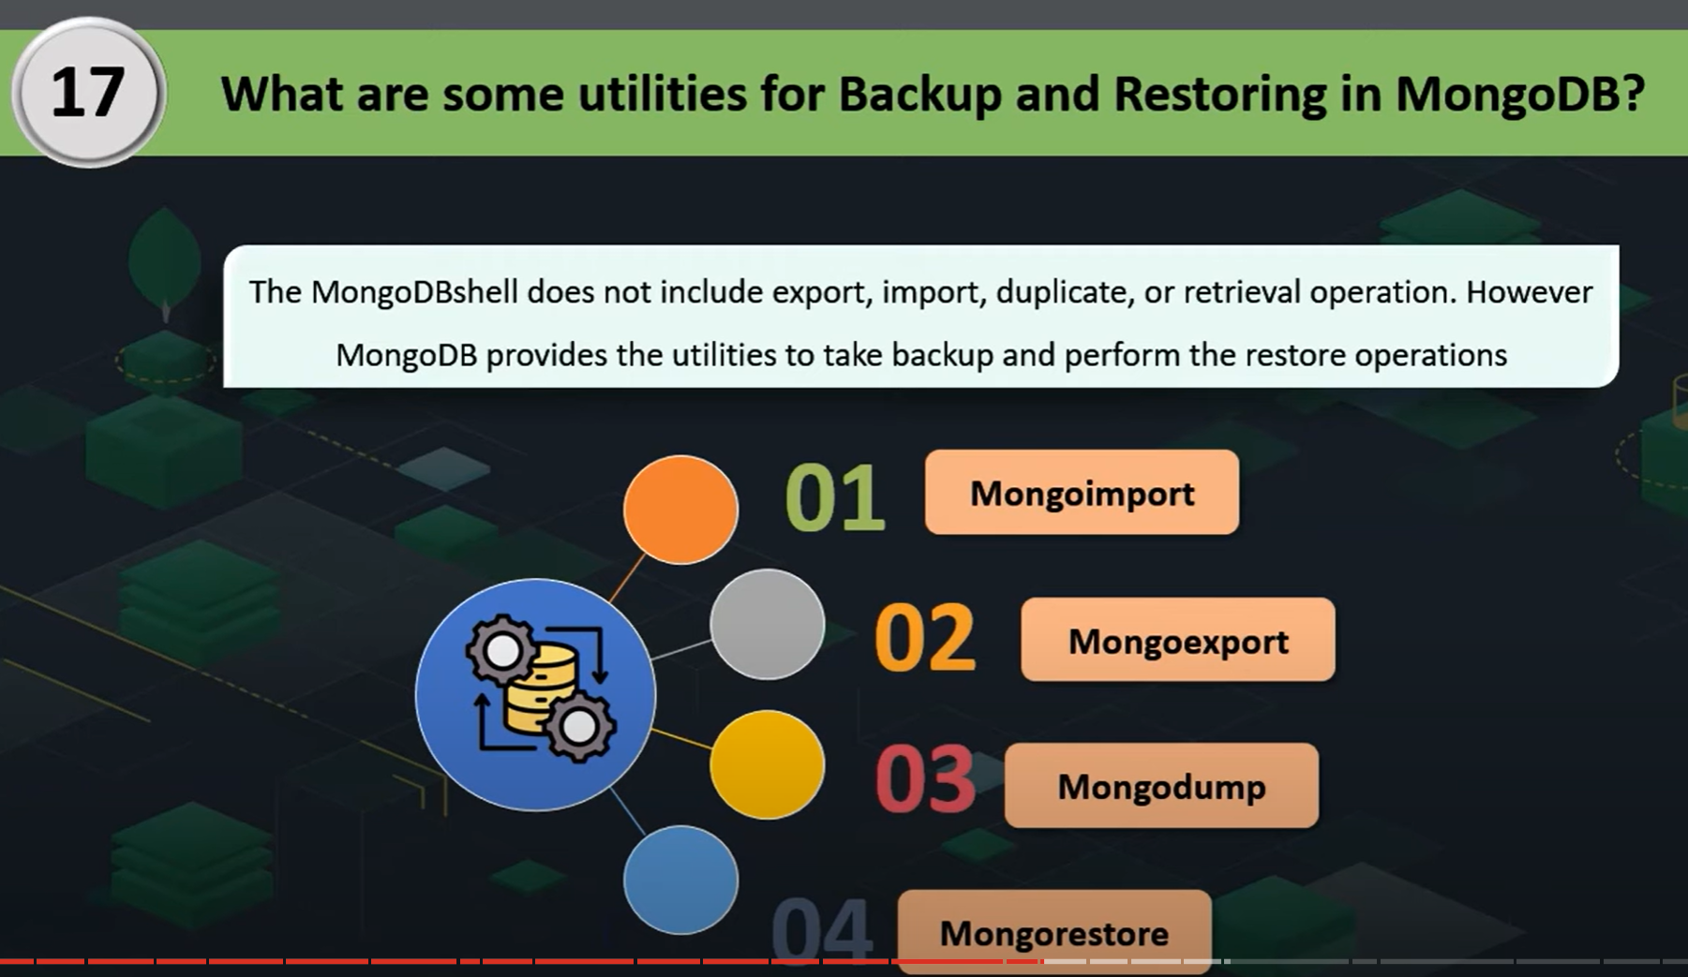

**How to Handle Backups and Disaster Recovery in MongoDB?**

Handling backups and disaster recovery in MongoDB involves regularly creating backups of your data and having a plan for restoring data in case of failure. Methods include:

* Mongodump/Mongorestore: Use the mongodump and mongorestore utilities to create and restore binary backups.
* File System Snapshots: Use file system snapshots to take consistent backups of the data files.
* Cloud Backups: If using MongoDB Atlas, leverage automated backups provided by the service.
* Replica Sets: Use replica sets to ensure data redundancy and high availability. Regularly test the failover and recovery process.

**What are Change Streams in MongoDB, and How are They Used?**

Change Streams in MongoDB allow applications to listen for real-time changes to data in collections, databases, or entire clusters. They provide a powerful way to implement event-driven architectures by capturing insert, update, replace, and delete operations. To use Change Streams, you typically open a change stream cursor and process the change events as they occur.

**Example:**

const changeStream = db.collection('orders').watch();  
changeStream.on('change', (change) => {  
 console.log(change);  
});

This example listens for changes in the orders collection and logs the change events.

**Explain the Use of Hashed Sharding Keys in MongoDB**

Hashed Sharding Keys in MongoDB distribute data across shards using a hashed value of the shard key field. This approach ensures an even distribution of data and avoids issues related to data locality or uneven data distribution that can occur with range-based sharding. Hashed sharding is useful for fields with monotonically increasing values, such as timestamps or identifiers.

**Example:**

db.collection.createIndex({ _id: "hashed" });  
sh.shardCollection("mydb.mycollection", { _id: "hashed" });

**33. How to Optimize MongoDB Queries for Performance?**

Optimizing MongoDB queries involves several strategies:

* **Indexes:** Create appropriate indexes to support query patterns.
* **Query Projections:** Use projections to return only necessary fields.
* **Index Hinting:**Use index hints to force the query optimizer to use a specific index.
* **Query Analysis:** Use the explain() method to analyze query execution plans and identify bottlenecks.
* **Aggregation Pipeline:** Optimize the aggregation pipeline stages to minimize data processing and improve efficiency.

**What is the Role of Journaling in MongoDB, and How Does It Impact Performance?**

Journaling in MongoDB ensures data durability and crash recovery by recording changes to the data in a journal file before applying them to the database files. This mechanism allows MongoDB to recover from unexpected shutdowns or crashes by replaying the journal. While journaling provides data safety, it can impact performance due to the additional I/O operations required to write to the journal file.

**36. How to Implement Full-Text Search in MongoDB?**

Full-Text Search in MongoDB is implemented using text indexes. These indexes allow you to perform text search queries on string content within documents.

**Example:**

db.collection.createIndex({ content: "text" });  
db.collection.find({ $text: { $search: "mongodb" } });

In this example, a text index is created on the content field, and a text search query is performed to find documents containing the word “mongodb.”

**What is an Index in MongoDB, and How to Create One?**

An index in MongoDB is a data structure that improves the speed of data retrieval operations on a collection. You can create an index using the createIndex method. For example, to create an index on the name field:

db.collection.createIndex({ name: 1 })

**Explain the Concept of Horizontal Scalability and Its Implementation in MongoDB**

Horizontal Scalability in MongoDB refers to the ability to add more servers to distribute the load and data. This is achieved through sharding, where data is partitioned across multiple shards. Each shard is a replica set that holds a subset of the data. Sharding allows MongoDB to handle large datasets and high-throughput operations by distributing the workload.

**39. How to Monitor and Troubleshoot Performance Issues in MongoDB?**

Monitoring and troubleshooting performance issues in MongoDB involve:

* Monitoring Tools: Use tools like MongoDB Cloud Manager, MongoDB Ops Manager, or third-party monitoring solutions.
* Logs: Analyze MongoDB logs for errors and performance metrics.
* Profiling: Enable database profiling to capture detailed information about operations.
* Explain Plans: Use the explain() method to understand query execution and identify bottlenecks.
* Index Analysis: Review and optimize indexes based on query patterns and usage.
* Resource Utilization: Monitor CPU, memory, and disk I/O usage to identify resource constraints.

**Describe the Process of Migrating Data from a Relational Database to MongoDB**

Migrating data from a relational database to MongoDB involves several steps:

* Schema Design: Redesign the relational schema to fit MongoDB’s document-oriented model. Decide on embedding vs. referencing, and plan for indexes and collections.
* Data Export: Export data from the relational database in a format suitable for MongoDB (e.g., CSV, JSON).
* Data Transformation: Transform the data to match the MongoDB schema. This can involve converting data types, restructuring documents, and handling relationships.
* Data Import: Import the transformed data into MongoDB using tools like mongoimport or custom scripts.
* Validation: Validate the imported data to ensure consistency and completeness.
* Application Changes: Update the application code to interact with MongoDB instead of the relational database.
* Testing: Thoroughly test the application and the database to ensure everything works as expected.
* Go Live: Deploy the MongoDB database in production and monitor the transition.

// Database Commands

show databases

// Lists all databases on the MongoDB server.

use myDatabase

// Switches to the database myDatabase. If it does not exist, it will be created upon inserting data.

db

// Displays the name of the current database.

show collections

// Lists all collections in the current database.

db.createCollection("myCollection")

// Creates a new collection named myCollection.

db.myCollection.drop()

// Deletes the collection myCollection.

// Document Commands

db.myCollection.insertOne({ name: "Alice", age: 25 })

// Inserts a single document into the collection myCollection.

db.myCollection.insertMany([{ name: "Bob", age: 30 }, { name: "Carol", age: 27 }])

// Inserts multiple documents into the collection myCollection.

db.myCollection.find()

// Retrieves and displays all documents from the collection myCollection.

db.myCollection.find({ age: { $gte: 25 } })

// Retrieves documents from myCollection where the age is greater than or equal to 25.

db.myCollection.findOne({ name: "Alice" })

// Retrieves the first document from myCollection where the name is "Alice".

db.myCollection.updateOne({ name: "Alice" }, { $set: { age: 26 } })

// Updates the age to 26 for the first document in myCollection where the name is "Alice".

db.myCollection.updateMany({ age: { $lt: 30 } }, { $set: { status: "young" } })

// Adds a "status" field with value "young" to all documents in myCollection where the age is less than 30.

db.myCollection.replaceOne({ name: "Alice" }, { name: "Roy", age: 26, status: "young" })

// Replaces the first document in myCollection where the name is "Alice" with a new document.

db.myCollection.deleteOne({ name: "Alice" })

// Deletes the first document in myCollection where the name is "Alice".

db.myCollection.deleteMany({ status: "young" })

// Deletes all documents in myCollection where the status is "young".

//--------------------------------Operators in MongoDB-----------------------------------

1. $eq (Equal)

// Matches documents where the value of a field is equal to the specified value.

db.myCollection.find({ age: { $eq: 30 } })

// Finds documents where the age field is equal to 30.

// Example output:

// { "_id": ObjectId("..."), "name": "Bob", "age": 30 }

2. $ne (Not Equal)

// Matches documents where the value of a field is not equal to the specified value.

db.myCollection.find({ age: { $ne: 30 } })

// Example output:

// [

//   { "_id": ObjectId("..."), "name": "Alice", "age": 25 },

//   { "_id": ObjectId("..."), "name": "Charlie", "age": 35 },

//   { "_id": ObjectId("..."), "name": "David", "age": 40 }

// ]

3. $gt (Greater Than)

// Matches documents where the value of a field is greater than the specified value.

db.myCollection.find({ age: { $gt: 30 } })

// Example output:

// [

//   { "_id": ObjectId("..."), "name": "Charlie", "age": 35 },

//   { "_id": ObjectId("..."), "name": "David", "age": 40 }

// ]

4. $gte (Greater Than or Equal To)

// Matches documents where the value of a field is greater than or equal to the specified value.

db.myCollection.find({ age: { $gte: 30 } })

// Example output:

// [

//   { "_id": ObjectId("..."), "name": "Bob", "age": 30 },

//   { "_id": ObjectId("..."), "name": "Charlie", "age": 35 },

//   { "_id": ObjectId("..."), "name": "David", "age": 40 }

// ]

5. $lt (Less Than)

// Matches documents where the value of a field is less than the specified value.

db.myCollection.find({ age: { $lt: 30 } })

// Example output:

// { "_id": ObjectId("..."), "name": "Alice", "age": 25 }

6. $lte (Less Than or Equal To)

// Matches documents where the value of a field is less than or equal to the specified value.

db.myCollection.find({ age: { $lte: 30 } })

// Example output:

// [

//   { "_id": ObjectId("..."), "name": "Alice", "age": 25 },

//   { "_id": ObjectId("..."), "name": "Bob", "age": 30 }

// ]

7. $in (In) // Matches any value in an array

// Matches documents where the value of a field equals any value in the specified array.

db.myCollection.find({ age: { $in: [25, 35] } })

// Example output:

// [

//   { "_id": ObjectId("..."), "name": "Alice", "age": 25 },

//   { "_id": ObjectId("..."), "name": "Charlie", "age": 35 }

// ]

8. $nin (Not In) // Does not match any value in an array

// Matches documents where the value of a field does not equal any value in the specified array.

db.myCollection.find({ age: { $nin: [25, 35] } })

// Example output:

// [

//   { "_id": ObjectId("..."), "name": "Bob", "age": 30 },

//   { "_id": ObjectId("..."), "name": "David", "age": 40 }

// ]

**What are TTL Indexes, and How are They Used in MongoDB?**

TTL (Time To Live) Indexes in MongoDB are special indexes that automatically remove documents from a collection after a certain period. They are commonly used for data that needs to expire after a specific time, such as session information, logs, or temporary data. To create a TTL index, you can specify the expiration time in seconds:

db.sessions.createIndex({ "createdAt": 1 }, { expireAfterSeconds: 3600 })

This index will remove documents from the sessions collection 1 hour (3600 seconds) after the createdAt field’s value.

**Describe the Aggregation Framework in MongoDB**

The Aggregation Framework in MongoDB is a powerful tool for performing data processing and transformation on documents within a collection. It works by passing documents through a multi-stage pipeline, where each stage performs a specific operation on the data, such as filtering, grouping, sorting, reshaping, and computing aggregations. This framework is particularly useful for creating complex data transformations and analytics directly within the database.



**Common Aggregation Pipeline Stages**

1. **$match**:
   * Filters documents by a specified condition, similar to the find method.
   * Example: Filter documents where the age is greater than 30.

javascript

Copy code

{

$match: { age: { $gt: 30 } }

}

1. **$group**:
   * Groups documents by a specified key and can apply aggregate functions like sum, avg, min, max, etc.
   * Example: Group documents by department and calculate the total salary.

javascript

Copy code

{

$group: { _id: "$department", totalSalary: { $sum: "$salary" } }

}

1. **$project**:
   * Shapes the documents by including, excluding, or adding new fields. It's similar to select in SQL.
   * Example: Include the name field and a computed field totalPrice (price * quantity).

javascript

Copy code

{

$project: { name: 1, totalPrice: { $multiply: ["$price", "$quantity"] } }

}

1. **$sort**:
   * Sorts the documents based on a specified field in ascending or descending order.
   * Example: Sort documents by createdAt in descending order.

javascript

Copy code

{

$sort: { createdAt: -1 }

}

1. **$limit**:
   * Limits the number of documents in the output.
   * Example: Limit to the first 5 documents.

javascript

Copy code

{

$limit: 5

}

1. **$skip**:
   * Skips a specified number of documents, often used for pagination.
   * Example: Skip the first 10 documents.

javascript

Copy code

{

$skip: 10

}

1. **$unwind**:
   * Deconstructs an array field into multiple documents, one per element.
   * Example: Unwind an array of tags, creating a new document for each tag.

javascript

Copy code

{

$unwind: "$tags"

}

1. **$lookup**:
   * Performs a left outer join with another collection, similar to SQL joins.
   * Example: Join the orders collection with the customers collection using customerId.

javascript

Copy code

{

$lookup: {

from: "customers",

localField: "customerId",

foreignField: "_id",

as: "customerDetails"

}

}

1. **$addFields**:
   * Adds or modifies fields in the documents.
   * Example: Add a new field fullName that concatenates the first and last name.

javascript

Copy code

{

$addFields: { fullName: { $concat: ["$firstName", " ", "$lastName"] } }

}

1. **$out**:
   * Writes the output of the aggregation pipeline to a new collection.
   * Example: Write the results to a collection named summary.

javascript

Copy code

{

$out: "summary"

}

1. **$replaceRoot / $replaceWith**:
   * Replaces the root document with a specified document.
   * Example: Replace the root document with the embedded address field.

javascript

Copy code

{

$replaceRoot: { newRoot: "$address" }

}

1. **$count**:
   * Counts the number of documents that pass through the pipeline and outputs the count.
   * Example: Count the total number of documents.

javascript

Copy code

{

$count: "totalDocuments"

}

1. **$facet**:
   * Allows running multiple aggregation pipelines within a single stage, returning multiple outputs in parallel.
   * Example: Return total count and list of documents in two separate pipelines.

javascript

Copy code

{

$facet: {

totalDocs: [{ $count: "count" }],

docs: [{ $skip: 0 }, { $limit: 10 }]

}

}

1. **$merge**:
   * Merges the results of the pipeline into an existing collection.
   * Example: Merge the pipeline results into a summary collection.

javascript

Copy code

{

$merge: { into: "summary", whenMatched: "merge", whenNotMatched: "insert" }

}

1. **$sample**:
   * Randomly selects a specified number of documents.
   * Example: Select a random sample of 5 documents.

javascript

Copy code

{

$sample: { size: 5 }

}

1. **$redact**:
   * Filters document fields based on access control rules or other conditions.
   * Example: Conditionally include or exclude certain fields from the output.

javascript

Copy code

{

$redact: {

$cond: {

if: { $eq: ["$secret", true] },

then: "$$PRUNE",

else: "$$KEEP"

}

}

}

1. **$set**:
   * Adds new fields to the documents, equivalent to $addFields.
   * Example: Set a new field status with a value of "active".

javascript

Copy code

{

$set: { status: "active" }

}

1. **$bucket**:
   * Categorizes documents into buckets based on a specified field.
   * Example: Bucket documents based on age into age groups.

javascript

Copy code

{

$bucket: {

groupBy: "$age",

boundaries: [0, 18, 30, 50, 80],

default: "Other",

output: { count: { $sum: 1 } }

}

}

1. **$bucketAuto**:
   * Automatically categorizes documents into a specified number of buckets based on an evenly distributed value range.
   * Example: Auto-bucket documents into 5 groups based on the price field.

javascript

Copy code

{

$bucketAuto: {

groupBy: "$price",

buckets: 5,

output: { count: { $sum: 1 } }

}

}

**Example Pipeline:**

Here’s a simple aggregation pipeline example that filters, groups, and sorts documents:

javascript

Copy code

db.orders.aggregate([

{ $match: { status: "completed" } }, // Filter by completed status

{ $group: { _id: "$customerId", totalSpent: { $sum: "$totalAmount" } } }, // Group by customer and sum the total amount

{ $sort: { totalSpent: -1 } }, // Sort by total spent in descending order

{ $limit: 10 } // Limit to the top 10 customers

]);

**Conclusion**

**MongoDB Query Based Interview Questions**

MongoDB Query-Based Interview Questions focus on your ability to write and optimize queries to interact with the database effectively. These questions typically include tasks like retrieving specific data using filters, sorting and paginating results, and using projection to select fields.

"[  
 {  
 ""_id"": 1,  
 ""name"": ""John Doe"",  
 ""age"": 28,  
 ""position"": ""Software Engineer"",  
 ""salary"": 80000,  
 ""department"": ""Engineering"",  
 ""hire_date"": ISODate(""2021-01-15"")  
 },  
 {  
 ""_id"": 2,  
 ""name"": ""Jane Smith"",  
 ""age"": 34,  
 ""position"": ""Project Manager"",  
 ""salary"": 95000,  
 ""department"": ""Engineering"",  
 ""hire_date"": ISODate(""2019-06-23"")  
 },  
 {  
 ""_id"": 3,  
 ""name"": ""Emily Johnson"",  
 ""age"": 41,  
 ""position"": ""CTO"",  
 ""salary"": 150000,  
 ""department"": ""Management"",  
 ""hire_date"": ISODate(""2015-03-12"")  
 },  
 {  
 ""_id"": 4,  
 ""name"": ""Michael Brown"",  
 ""age"": 29,  
 ""position"": ""Software Engineer"",  
 ""salary"": 85000,  
 ""department"": ""Engineering"",  
 ""hire_date"": ISODate(""2020-07-30"")  
 },  
 {  
 ""_id"": 5,  
 ""name"": ""Sarah Davis"",  
 ""age"": 26,  
 ""position"": ""UI/UX Designer"",  
 ""salary"": 70000,  
 ""department"": ""Design"",  
 ""hire_date"": ISODate(""2022-10-12"")  
 }  
]"

**1. Find all Employees Who Work in the “Engineering” Department.**

**Query:**

db.employees.find({ department: "Engineering" })

**Output:**

[  
 {  
 "_id": 1,  
 "name": "John Doe",  
 "age": 28,  
 "position": "Software Engineer",  
 "salary": 80000,  
 "department": "Engineering",  
 "hire_date": ISODate("2021-01-15")  
 },  
 {  
 "_id": 2,  
 "name": "Jane Smith",  
 "age": 34,  
 "position": "Project Manager",  
 "salary": 95000,  
 "department": "Engineering",  
 "hire_date": ISODate("2019-06-23")  
 },  
 {  
 "_id": 4,  
 "name": "Michael Brown",  
 "age": 29,  
 "position": "Software Engineer",  
 "salary": 85000,  
 "department": "Engineering",  
 "hire_date": ISODate("2020-07-30")  
 }  
]

**Explanation:**

This query finds all employees whose department field is “Engineering”.

**2. Find the Employee with the Highest Salary.**

**Query:**

db.employees.find().sort({ salary: -1 }).limit(1)

**Output:**

[  
 {  
 "_id": 3,  
 "name": "Emily Johnson",  
 "age": 41,  
 "position": "CTO",  
 "salary": 150000,  
 "department": "Management",  
 "hire_date": ISODate("2015-03-12")  
 }  
]

**Explanation:**

This query sorts all employees by salary in descending order and retrieves the top document, which is the employee with the highest salary.

**3. Update the Salary of “John Doe” to 90000.**

**Query:**

db.employees.updateOne({ name: "John Doe" }, { $set: { salary: 90000 } })

**Output:**

{ "acknowledged" : true, "matchedCount" : 1, "modifiedCount" : 1 }

**Explanation:**

This query updates the salary of the employee named “John Doe” to 90000.

**4. Count the Number of Employees in Each Department.**

**Query:**

db.employees.aggregate([  
 { $group: { _id: "$department", count: { $sum: 1 } } }  
])

**Output:**

[  
 { "_id": "Engineering", "count": 3 },  
 { "_id": "Management", "count": 1 },  
 { "_id": "Design", "count": 1 }  
]

**Explanation:**

This query groups the employees by the department field and counts the number of employees in each department.

**5. Add a New Field Bonus to All Employees in the “Engineering” Department with a Value of 5000.**

**Query:**

db.employees.updateMany({ department: "Engineering" }, { $set: { bonus: 5000 } })

**Output:**

{ "acknowledged" : true, "matchedCount" : 3, "modifiedCount" : 3 }

**Explanation:**

This query adds a new field bonus with a value of 5000 to all employees in the “Engineering” department.

**6. Retrieve All Documents in the Employees Collection and Sort Them by the Length of Their Name in Descending Order.**

**Query:**

db.employees.aggregate([  
 { $addFields: { nameLength: { $strLenCP: "$name" } } },  
 { $sort: { nameLength: -1 } },  
 { $project: { nameLength: 0 } }  
])

**Output:**

[  
 {  
 "_id": 2,  
 "name": "Jane Smith",  
 "age": 34,  
 "position": "Project Manager",  
 "salary": 95000,  
 "department": "Engineering",  
 "hire_date": ISODate("2019-06-23")  
 },  
 {  
 "_id": 3,  
 "name": "Emily Johnson",  
 "age": 41,  
 "position": "CTO",  
 "salary": 150000,  
 "department": "Management",  
 "hire_date": ISODate("2015-03-12")  
 },  
 {  
 "_id": 1,  
 "name": "John Doe",  
 "age": 28,  
 "position": "Software Engineer",  
 "salary": 80000,  
 "department": "Engineering",  
 "hire_date": ISODate("2021-01-15")  
 },  
 {  
 "_id": 4,  
 "name": "Michael Brown",  
 "age": 29,  
 "position": "Software Engineer",  
 "salary": 85000,  
 "department": "Engineering",  
 "hire_date": ISODate("2020-07-30")  
 },  
 {  
 "_id": 5,  
 "name": "Sarah Davis",  
 "age": 26,  
 "position": "UI/UX Designer",  
 "salary": 70000,  
 "department": "Design",  
 "hire_date": ISODate("2022-10-12")  
 }  
]

**Explanation:**

This query calculates the length of each employee’s name, sorts the documents by this length in descending order, and removes the temporary nameLength field from the output.

**7. Find the Average Salary of Employees in the “Engineering” Department.**

**Query:**

db.employees.aggregate([  
 { $match: { department: "Engineering" } },  
 { $group: { _id: null, averageSalary: { $avg: "$salary" } } }  
])

**Output:**

[  
 { "_id": null, "averageSalary": 86666.66666666667 }  
]

**Explanation:**

This query filters employees to those in the “Engineering” department and calculates the average salary of these employees.

**8. Find the Department with the Highest Average Salary.**

**Query:**

db.employees.aggregate([  
 { $group: { _id: "$department", averageSalary: { $avg: "$salary" } } },  
 { $sort: { averageSalary: -1 } },  
 { $limit: 1 }  
])

**Output:**

[  
 { "_id": "Management", "averageSalary": 150000 }  
]

**Explanation:**

This query groups employees by department, calculates the average salary for each department, sorts these averages in descending order, and retrieves the department with the highest average salary.

**9. Find the Total Number of Employees Hired in Each Year.**

**Query:**

db.employees.aggregate([  
 { $group: { _id: { $year: "$hire_date" }, totalHired: { $sum: 1 } } }  
])

**Output:**

[  
 { "_id": 2015, "totalHired": 1 },  
 { "_id": 2019, "totalHired": 1 },  
 { "_id": 2020, "totalHired": 1 },  
 { "_id": 2021, "totalHired": 1 },  
 { "_id": 2022, "totalHired": 1 }  
]

**Explanation:**

This query groups employees by the year they were hired, which is extracted from the hire_date field, and counts the total number of employees hired each year.

**10. Find the Highest and Lowest Salary in the “Engineering” Department.**

**Query:**

db.employees.aggregate([  
 { $match: { department: "Engineering" } },  
 {  
 $group: {  
 _id: null,  
 highestSalary: { $max: "$salary" },  
 lowestSalary: { $min: "$salary" }  
 }  
 }  
])

**Output:**

[  
 { "_id": null, "highestSalary": 95000, "lowestSalary": 80000 }  
]

**Explanation:**